PATUAKHALI SCIENCE AND TECHNOLOGY UNIVERSITY



**Assignment Name: Lab Problem 01**

**Course Code: CCE-314**

**Course Title: Computer Networks Sessional**

Submitted to:

**Dr. Md. Samsuzzaman**

Professor

Department of Computer and Communication Engineering

Faculty of Computer Science and Engineering

Submitted by:

**Mir Suhail Asarat**

ID No.: 2002019

Registration No.: 09536

Level-3, Semester-1, Session: 2020-2021

Faculty of Computer Science & Engineering

Date of Submission: April 26, 2023

# Session 1: Building a Local Area Network

## Objectives

1. To learn basics of Local Area Network (LAN)
2. Understand different types of LAN devices
3. To learn procedure to make Unshielded Twisted-Pair (UTP) cable

## Description

### What is a LAN?

A LAN is a high-speed data network that covers a relatively small geographic area. It typically connects workstations, personal computers, printers, servers, and other devices. LANs offer computer users many advantages, including shared access to devices and applications, file exchange between connected users, and communication between users via electronic mail and other applications.

### LAN Protocols and the OSI Reference Model

LAN protocols function at the lowest two layers of the OSI reference model i.e. between the physical layer and the data link layer. *Figure 1* illustrates how several popular LAN protocols map to the OSI reference model.

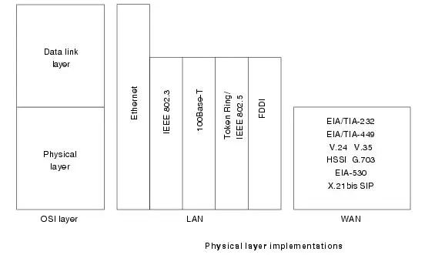

**Figure 1***:* Popular LAN Protocols Mapped to the OSI Reference Model

### LAN Devices:

1. **NIC (Network Interface Card):** Also called Network Adapter. It connects a host to a network medium. It provides the physical interface between computers and cabling. It prepares data, sends data, and controls the flow of data. It can also receive and translate data into bytes for the CPU to understand. Contains unique MAC Address to control data communication.
2. **Repeater:** Functioning at Physical Layer. A **repeater** is an electronic device that receives a signal and retransmits it at a higher level and/or higher power, or on to the other side of an obstruction, so that the signal can cover longer distances. Repeaters have two ports, so cannot be used to connect for more than two devices.
3. **Hub:** An **Ethernet hub**, **active hub**, **network hub**, **repeater hub**, **hub** or **concentrator** is a device for connecting multiple twisted pair or fiber optic Ethernet devices together and making them act as a single network segment. Hubs work at the physical layer (layer 1) of the OSI model. The device is a form of multi-port repeater. Repeater hubs also participate in collision detection, forwarding a jam signal to all ports if it detects a collision.
4. **Switch:** A **network switch** or **switching hub** is a computer networking device that connects network segments. The term commonly refers to a network bridge that processes and routes data at the Data link layer (layer 2) of the OSI model. Switches that additionally process data at the network layer (layer 3 and above) are often referred to as Layer 3 switches or multilayer switches.
5. **Bridge:** A **network bridge** connects multiple network segments at the data link layer (Layer 2) of the OSI model. In Ethernet networks, the term *bridge* formally means a device that behaves according to the IEEE802.1 standard. A bridge and switch are very much alike; a switch being a bridge with numerous ports. Bridges can analyze incoming data packets to determine if the bridge is able to send the given packet to another segment of the network.
6. **Router:** A **router** is an electronic device that interconnects two or more computer networks, and selectively interchanges packets of data between them. Each data packet contains address information that a router can use to determine if the source and destination are on the same network, or if the data packet must be transferred from one network to another. Where multiple routers are used in a large collection of interconnected networks, the routers exchange information about target system addresses, so that each router can build up a table showing the preferred paths between any two systems on the interconnected networks.
7. **Gate Way:** A **gateway** is a hardware device that acts as a "gate" between two networks. A gateway may contain devices such as protocol translators, impedance matching devices, rate converters, fault isolators, or signal translators as necessary to provide system interoperability.

### UTP Cable Construction:

1. **Cross Over Cable:** Diagram shows how to prepare Cross Over Connection.

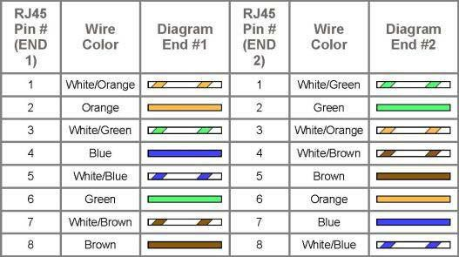

1. **Straight Through Cable:** Diagram shows how to prepare Straight Through Connection.

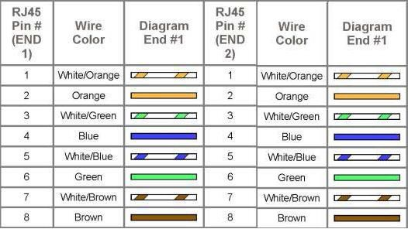

# Session 2: Concept of Network IP Address (Part-1)

## Objectives:

* 1. Study of Class-full IP Addressing
  2. To learn Classes, Blocks and Masking

## Description

**IP Addressing v4:** The identifier used in the network layer to identify each device connected to the Internet is called the Internet address or IP address**.**

### Rules for Class full addressing:

1. The format of IP address IPv4 is made up of four parts, in the pattern as w.x.y.z. Each part has 8 binary bits and the values in decimal can range from 0 to 255.
2. IP addresses are divided into different classes. These classes determine the maximum number of hosts per network ID. Only three classes are used for network connectivity. The following table lists all of the addresses of class.

|  |  |  |
| --- | --- | --- |
| **Class** | **Address Range** | **Supports** |
| **Class A** | 1.0.0.1 to 126.255.255.254 | Supports 16 million hosts on each of 127 networks. |
| **Class B** | 128.1.0.1 to 191.255.255.254 | Supports 65,000 hosts on each of 16,000 networks. |
| **Class C** | 192.0.1.1 to 223.255.254.254 | Supports 254 hosts on each of 2 million networks. |
| **Class D** | 224.0.0.0 to 239.255.255.255 | Reserved for multicast groups. |
| **Class E** | 240.0.0.0 to 254.255.255.254 | Reserved. |

1. Grouping of IP addresses into different classes.
   1. Class A, B, C, D, E
   2. Class A: first bit in w is 0 and others can be anything
      1. 0.0.0.0 to 127.255.255.255
      2. The first bits are used for the network part and the remaining for the host part.
   3. Class B: First bit in w is 1 and second bit is 0.
      1. 128.0.0.0 to 191.255.255.255
      2. First 16 bits for network part and remaining host part
   4. Class C: first bit in w is 1, second bit in w is 1 and third bit is 0
      1. 192.0.0.0 to 223.255.255.255
      2. First 24 bits for the network part and last 8 bits for host part.
   5. Class D: first, second, third bits in w are 1 and fourth bit is 0; used for multicast.
      1. 224.0.0.0 to 247.255.255.255
   6. Class E: future use or experimental purposes.
2. Default Subnet mask it is used to identify the network part from the host part. Put binary one for the parts that represent network part and zero for the part that represents host part.
   1. Class A: 255.0.0.0
   2. Class B: 255.255.0.0
   3. Class C: 255.255.255.0
   4. We can’t have mix of 1s and 0s in subnet mask. Only consecutive 1s is followed by consecutive 0s.

# Session 3: Concept of Network IP Address (Part-2)

# Objectives

1. Study of Classless IP Addressing
2. To learn the concept of Sub netting and Super netting

## Description

### Why Class less Addressing?

To overcome address depletion and give more organizations access to the Internet, classless addressing was designed and implemented. In this scheme, there are no classes, but the addresses are still granted in blocks.

**Rules for Class less addressing**

1. The format of **Class less** is made up of **variable-length block with** the slash notation **A.B.C.D/n.** Slash notation **n** is also called CIDR (Class less Interdomain Routing) notation/prefix length represented using ‘1’, as masking.
2. The addresses in a block must be contiguous, one after another.
3. The number of addresses in a block must be a power of 2 (1, 2, 4, 8, ... ).
4. The first address must be evenly divisible by the number of addresses.

### Subnetting

A network is divided into several smaller networks. Each smaller network is called a **Subnetwork** or a **Subnet**.

The following topics will be discussed:

1. Why do we Develop Subnetting?
2. How to calculate Subnet mask?
3. How to identify Subnet address?

### Supernetting

In Supernetting, an organization can combine several class C blocks to create a large range of addresses. The following topics will be discussed:

1. Why we Develop Supernetting?
2. How to calculate Supernet mask?
3. How to identify Supernet address?

# Session 4: Introduction to Network Simulator – Packet Tracer

# Objectives

1. Introduction to Packet Tracer Interface
2. To learn how to use different components and build a simple network

## Description

**Packet Tracer** is a protocol simulator developed by Dennis Frezzo and his team at Cisco Systems. Packet Tracer (PT) is a powerful and dynamic tool that displays the various protocols used in networking, in either Real Time or Simulation mode.

**Packet Tracer Interface and how to create a topology**

Step 1: Start Packet Tracer and Enter into Simulation Mode

Step 2: Choose Devices and Connections

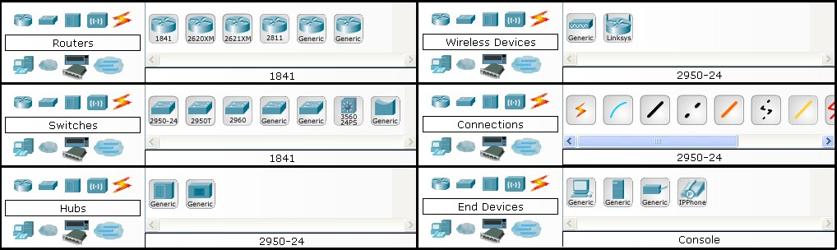

Step 3: Building the Topology – Adding Hosts in following way:

* + Single click on the End Devices.
  + Single click on the Generic host.
  + Move the cursor into topology area. You will notice it turns into a plus “+” sign. Single click in the topology area and it copies the device.

Step 4: Building the Topology – Connecting the Hosts to Hubs and Switches

* + Adding a Hub or Switch: Select a hub or a switch by clicking once on Hubs/Switches and once on a Generic hub/Switch.
  + Connect Host to Hub/Switch by first choosing Connections.
  + Click once on the Copper Straight-through cable.

Step 5: Configuring IP Addresses and Subnet Masks on the Hosts

* + Click once on PC0.
  + Choose the Config tab.
  + Click on FastEthernet.
  + Enter IP address and Subnet Mask.

## Exercises

1. Design a topology using 4 PC and a Switch with following IP address:

|  |  |  |
| --- | --- | --- |
| Host | IP Address | Subnet Mask |
| PC0 | 192.68.1.10 | 255.255.255.0 |
| PC1 | 192.68.1.11 | 255.255.255.0 |
| PC2 | 192.68.1.12 | 255.255.255.0 |
| PC3 | 192.68.1.13 | 255.255.255.0 |

**Answer:**

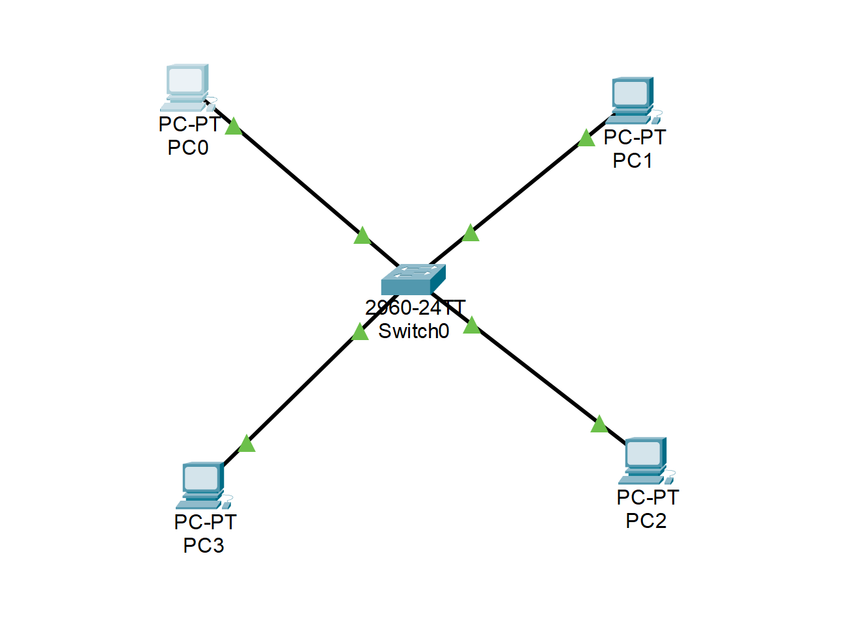

1. Observe the flow of data from host to host by creating network traffic.

**Session 5: Configuration of a Router using Packet Tracer**

Usually, we configure Home Routers by using PPPoE connection type.